MED D - Blue MedicareRx (NEJE) - Late Enrollment Penalty (LEP) Attestation and Appeals

General Information
LEP Standard Guidance
LEP Mailings - Annual Changes and Invoices
Identifying LEP in PeopleSafe
Taking a Verbal Attestation
Resolution Time
LEP Appeal Process
Reconsideration Requests (LEP Appeals)
Closing the Call
Resolution Time
Exceptions
FAQs
Related Documents

Description: This document will assist the MED D Customer Care Representative (CCR) with understanding the Late Enrollment Penalty (LEP) for Medicare Part D, identifying the LEP in PeopleSafe and providing processes on how to address the beneficiary’s LEP issues.

General Information

The Late Enrollment Penalty (LEP) is assessed as 1% of the National Base beneficiary Premium for the coverage year times the total number of uncovered months, rounded to the nearest ten cents.
- The LEP is added to the beneficiary’s monthly premium for long as s/he remains enrolled in a Medicare prescription drug plan.

The penalty is assessed if there is a continuous period of 63 days or more at any time after the end of the individual’s Part D Initial Enrollment Period (IEP) during which the individual was eligible to enroll in a Part D plan but was not enrolled in a Part D plan and was not covered under any creditable prescription drug coverage.
- Those who do not enroll in Part D when first eligible may be subject to an LEP if they decide to enroll later at a later date.
- When a new beneficiary enrolls in a Part D plan, the plan is responsible for determining whether the person was previously enrolled in another Part D plan or had other creditable coverage prior to enrolling in the plan, and whether there were any lapses in creditable coverage greater than 63 days.
- Creditable coverage is defined as prescription drug coverage that equals or exceeds the actuarial value of defined standard Part D prescription drug coverage, (coverage that is at least as good as Medicare’s prescription drug coverage).
- Depending on the date the person enrolled, the plan may be able to get this information from:
  - The beneficiary’s enrollment form
  - Submitting a query to CMS
  - Sending the beneficiary an attestation form (Declaration of Prior Prescription Drug Coverage form)
    - The attestation form advises the beneficiary that they have 30 calendar days to respond, telling the plan whether s/he had creditable coverage during the dates in question.
    - Any attestation information received after the 30 day deadline must be processed by the plan within 60 days.
    - The attestation form requests that the beneficiary provide the source of their creditable coverage, the dates of creditable coverage and a signature from the beneficiary or the beneficiary’s POA (Power of Attorney).
    - The form can be returned via mail to Blue MedicareRx (PDP), PO BOX 30016, Pittsburgh, PA 15222-0330 or the information can be provided over the phone to MED D Customer Care at:
      - MA: 888-543-4917
      - CT: 888-620-1747
      - VT: 888-620-1746
      - RI: 888-620-1748
    - If the beneficiary attests to Partial Coverage or No Coverage, the letter will be mailed out in approximately 7 days. If the beneficiary attests to Full Coverage, a letter will NOT be mailed out.

Refer to MED D - Late Enrollment Penalty Attestation and Appeals and MED D - Blue MedicareRx (NEJE) - LEP Verbal Attestation Form.

- Once the plan has determined whether or not a beneficiary has had a lapse in coverage greater than 63 days, the plan informs CMS so that CMS can compute the LEP in those cases where a penalty is owed.

CMS is the only entity authorized to calculate and impose an LEP.
- The plan may not estimate or inform a beneficiary of the penalty amount until it receives formal notification of the penalty amount from CMS.
- Within 10 calendar days of receiving this formal notification from CMS, the plan must write to the beneficiary and advise him or her of the penalty amount.
- If the plan receives an incomplete attestation, the beneficiary has 28 days from the date the attestation is originally received to provide information to complete the attestation.

Top of the Document

LEP Standard Guidance
Beneficiaries may be sent an attestation form (Declaration of Prior Prescription Drug Coverage form) to request evidence of creditable coverage if the plan does not have record of any.
- The beneficiary then has 30 days from the date of letter to respond.
- If the beneficiary returns the documentation /calls within 30 days of the attestation form and states that they had Creditable Coverage, the plan has 14 days from receipt to submit to Medicare.
- If the beneficiary returns the documentation/calls within 30 days and states they did NOT have Creditable Coverage, the Plan will submit this information to Medicare.
    - The form can be returned via mail to Blue MedicareRx (PDP), PO BOX 30016, Pittsburgh, PA 15222-0330 or the information can be provided over the phone to Blue MedicareRx Customer Care at:
MA: 888-543-4917
CT: 888-620-1747
RI: 888-620-1748
VT: 888-620-1746
<24 hours a day, 7 days a week>
      - TTY users call <711>
- If the attestation is received within the allotted time but is incomplete, the plan will make 3 attempts via phone to obtain the complete information from the beneficiary over the next three days from the date the incomplete document was received. If the OBCs are unsuccessful, a letter will be sent to the beneficiary and they will have until the 30th day following the date of the original attestation letter to provide the missing information, or they will be subjected to the LEP.
- If the attestation is not received until the 31st day or after, the Notice of Creditable Coverage Information Received after Deadline Date letter will be sent to the beneficiary, informing that the LEP information was already sent to Medicare.
- The plan notifies the beneficiary of any LEP by sending the LEP letter and reconsideration form.

Top of the Document

LEP Mailings - Annual Changes and Invoices

At the start of each calendar year, the beneficiary’s LEP amount will change based on the change to the national base beneficiary premium.
- Part D plan sponsors will adjust premium bills accordingly to reflect the new amount and include notification of this new amount in the beneficiaries’ premium bills or via a separate notice.
  - Refer to the MED D - Exhibit 9 NEJE Model Notice of Yearly Change to LEP S2893_15157_LEP.

Top of the Document

Identifying LEP in PeopleSafe

In order to identify the LEP in PeopleSafe, the CCR will follow the steps listed below:
Step | Action
1 | Is the caller the beneficiary, POA, Legal Representative or Ship Counselor?
1 | If the caller is… |  |  | Then…
1 | Beneficiary |  |  | Proceed to next step.
1 | Legal Representative |  |  | If… | Then…
1 |  |  |  | Yes | Proceed to next step.
1 |  |  |  | No | Determine if the Plan has POA information on file.  Refer to: MED D - Appointed Representative Form (AOR) or Power of Attorney (POA).  If the caller is not listed under POA/Authorized Rep Details, advise the caller to fill out the Declaration of Prior Prescription Drug Coverage form that was previously mailed to the beneficiary should be mailed to:  Blue MedicareRx  PO Box 30001  Pittsburgh, PA 15222-0330  OR fax to: JE Fax 866-342-7048  Blue MedicareRx (NEJE): MED D - Blue MedicareRx (NEJE) - LEP Verbal Attestation Form  CCR Process Note: The CCR must put detailed notes in PeopleSafe Med D Inquiry tab that the non-authorized party is aware of the verbal attestation process.  Proceed to Closing the Call.
1 | Ship Counselor |  |  | Refer to MED D - SHIP Counselor Calls for Part D Plans.  Proceed to next step.
2 | On the Main screen, click on the Medicare Part D Inquiry tab.  
3 | Determine if an attestation has been submitted to CMS or the status of the CMS review by selecting View Comments.
3 | If... |  | Then...
3 | Has NOT been submitted |  | Offer verbal attestation via RxEnroll.
3 | Has been previously submitted, but now has new information to add |  | Offer verbal attestation via RxEnroll.
3 | Has been previously submitted and there is NO new information to add |  | Provide Exceptions information and submit LEP IRE Reconsideration Packet from Fulfillment Requests in Med D tab
4 | Click on the Plan Details tab.  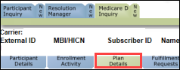  Note: Check last 12 months communication link to view letter and confirm with beneficiary missing dates.
5 | Inform the beneficiary of the late enrollment penalty amount that is being applied to his/her MED D monthly premium.  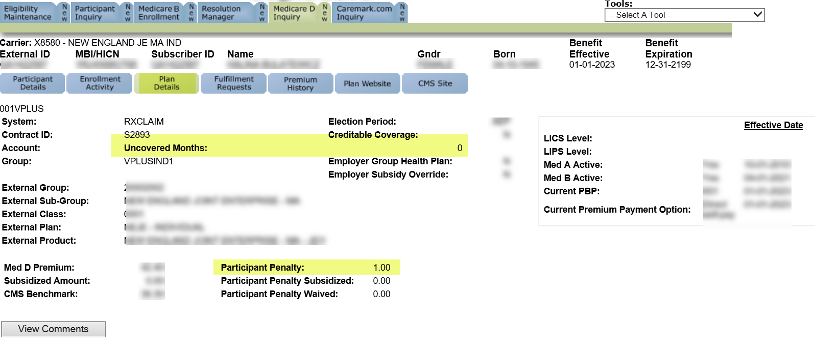
6 | Identify the reason the beneficiary (or third party) is calling.
6 | If… |  |  | Then…
6 | The caller needs to attest to coverage or questions their LEP. |  |  | Proceed to Taking a Verbal Attestation.
6 | The caller references a letter regarding their LEP. |  |  | Proceed to Step 2 of Taking a Verbal Attestation.
6 | The caller refers to a reconsideration request or needs a duplicate form. |  |  | Proceed to Reconsideration Requests (LEP Appeals)
6 | The caller has no further questions. |  |  | Proceed to Closing the Call.
7 | Ask if there are any other benefit questions.
7 | If… | Then…
7 | Yes | Address any benefit issues.  Document and close the call according to current policies and procedures.  Refer to the MED D - Call Documentation work instruction.  Log Activity  1327 = Premium Billing
7 | No | Document and close the call according to current policies and procedures.  Refer to the MED D - Call Documentation work instruction.  Log Activity  1327 = Premium Billing

Top of the Document

Taking a Verbal Attestation

Perform the following:
Step | Action
1 | Is the caller the beneficiary, POA, Legal Representative or Ship Counselor?
1 | If the caller is… | Then…
1 | Beneficiary | Proceed to next step.
1 | Legal representative | To process an attestation for (Beneficiary’s Name), I need to verify that you are authorized to act on his/her behalf under the laws of the State in which the beneficiary resides. If asked to provide evidence of that authority to <Blue MedicareRx (NEJE)> or Medicare, would you be able to do so?
1 | Legal representative | If… | Then…
1 | Legal representative | Yes | Proceed to next step.
1 | Legal representative | No | Determine if the Plan has POA information on file.  Refer to: MED D - Appointed Representative Form (AOR) or Power of Attorney (POA).  If the caller is not listed under POA/Authorized Rep Details, advise the caller to fill out the Declaration of Prior Prescription Drug Coverage form that was previously mailed to the beneficiary should be mailed to:  Blue MedicareRx  PO Box 30001  Pittsburgh, PA 15222-0330  OR fax to: JE Fax 866-342-7048  Blue MedicareRx (NEJE): MED D - Blue MedicareRx (NEJE) - LEP Verbal Attestation Form  CCR Process Note: The CCR must put detailed notes in PeopleSafe Med D Inquiry tab that the non-authorized party is aware of the verbal attestation process.  Proceed to Closing the Call.
1 | Ship Counselor | Refer to MED D - SHIP Counselor Calls For Part D Plans.  Proceed to next step.
2 | Review the LEP letter sent to the beneficiary (DLEP).  - Click on the Medicare D Inquiry Tab and click on the Last 12 months of Medicare Communication button to review the DLEPL letter.  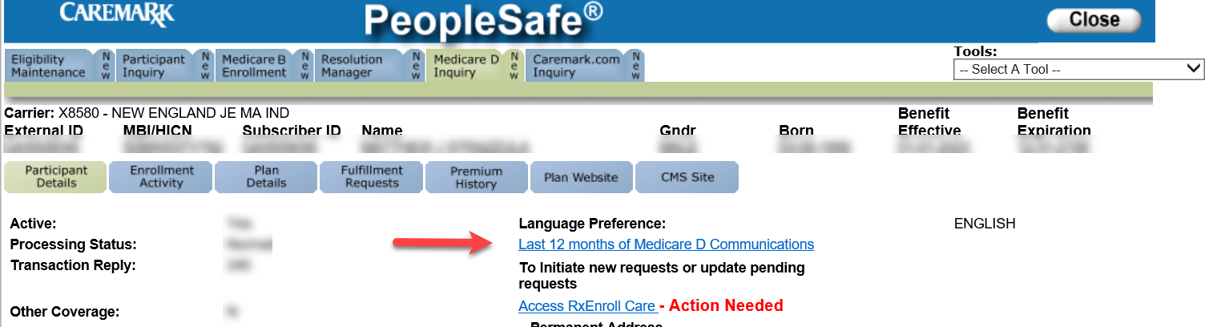  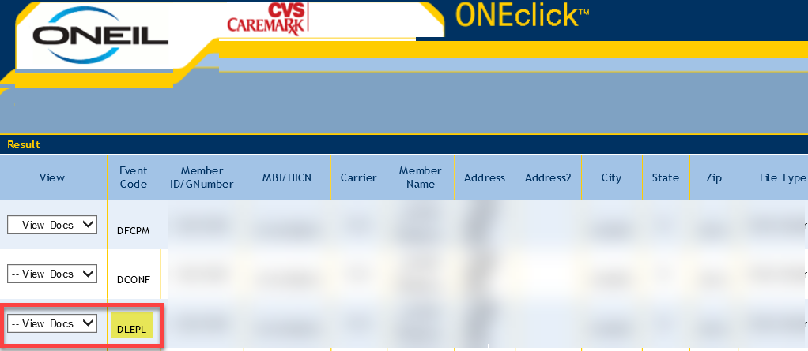  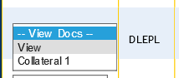  - Verify if the caller is contacting the plan within the 90 days from when the Attestation letter was sent.  Example:  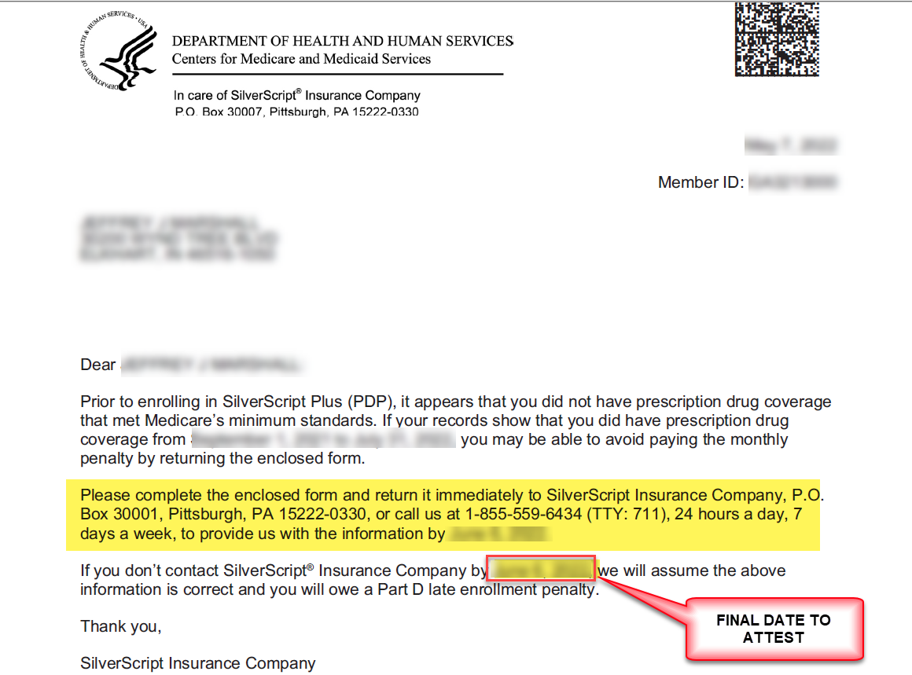  Note: Refer to the Declaration of Prior Prescription Drug Coverage form (Blue MedicareRx (NEJE): MED D - Blue MedicareRx (NEJE) - LEP Verbal Attestation Form) and review the information in the form with the caller.
3 | Perform the following:
3 | If the caller is… |  |  | Then…
3 | Contacting us within the 90-day window |  |  | Proceed to next step.
3 | Contacting us after the 90-day window  OR  Beneficiary is disputing the number of uncovered months and 90 days have passed since the Attestation Letter was sent  OR  Existing LEP assessed by a prior plan |  |  | Proceed to Reconsideration Requests (LEP Appeals)
4 | Determine the correct dates needed by referencing the Attestation letter (Click on the Medicare D Inquiry Tab and click on the Last 12 months of Medicare Communication button to review the letter if not previously open from Step 2.)  Example:  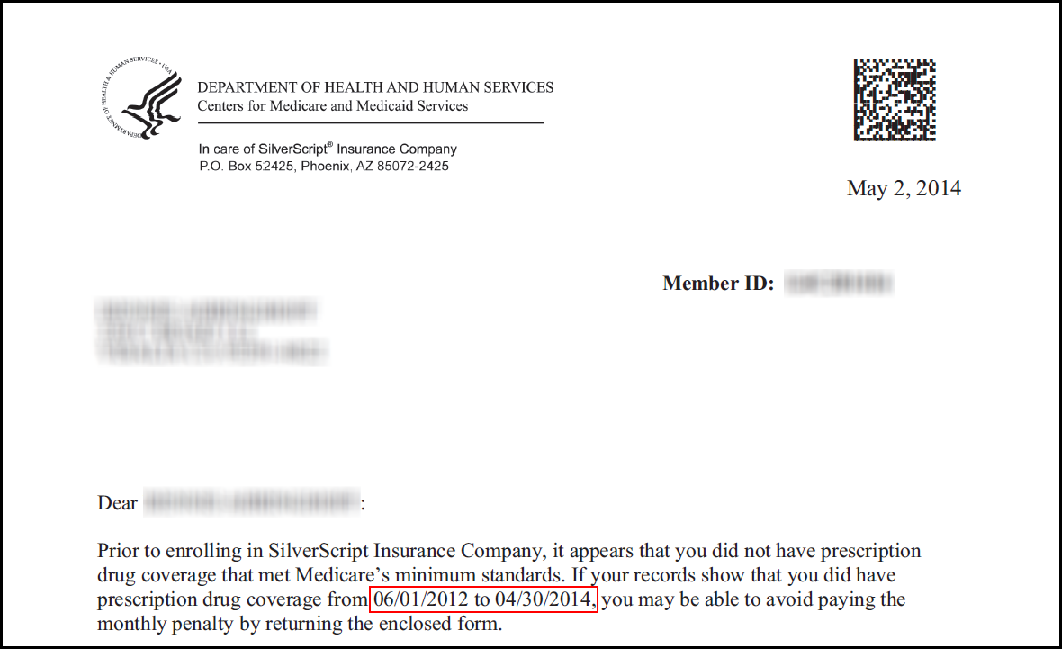
5 | Would you like help completing the form that you received with your letter or would you prefer I submit a verbal attestation for you today?
5 | If the caller wants… | Then…
5 | To submit a verbal attestation | Perform the following:
5 | To submit a verbal attestation | Step | Action
5 | To submit a verbal attestation | 1 | Click the Access RxEnroll Care link located on the Participant Details screen of the Medicare D Inquiry tab in PeopleSafe.  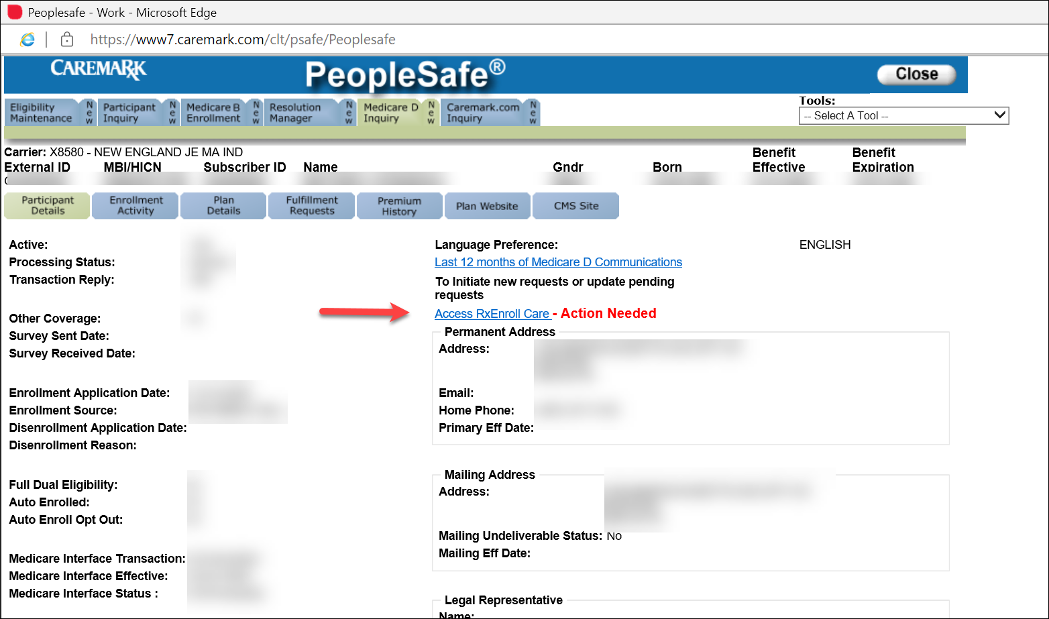  Note: If RxEnroll Care is unavailable, create an RM task in PeopleSafe for the following:  Task Category: Medicare D Enrollment - Enrollment  Task Type: Late Enrollment Penalty  Queue: Med D Enrollment Task  - Medicare requires that you have creditable prescription drug coverage, that is equal to or better than the coverage that Medicare provides.  - If you did not have creditable prescription drug coverage, your premium may be higher.  - We sent you a letter to let you know that there may be a gap in your Medicare Part D prescription drug coverage.  Document details in the task Note section for the following questions.  - Did you have creditable prescription drug coverage during the timeframe included in your letter?  - What was the start date for your coverage?  - What was the end date for your coverage?  If needed provide Legal Rep or POA (Full name, address, and phone number, and relationship to the beneficiary).  CCR Process Note: Copy the note to use for closing the call.
5 | To submit a verbal attestation | 2 | Determine if the beneficiary had creditable prescription drug coverage for the LEP gap dates in question by reading the prompt under Coverage Confirmation.
5 | To submit a verbal attestation | 2 | If the caller answer is… |  | Then…
5 | To submit a verbal attestation | 2 | Yes |  | The beneficiary had coverage for all, or part of the span shown under Coverage confirmation.  - Select Yes.  Note: If the beneficiary was residing outside of the country/service area OR if the beneficiary was incarcerated during the dates in his/her letter, this time span should be entered as creditable prescription drug coverage with coverage type other. Clearly notate PeopleSafe and RxEnroll Care to indicate the beneficiary should not be assessed an LEP during a timeframe that he/she did not qualify for enrollment in a Part D plan.  I can assist you with filling out the form you received by mail or you may submit your attestation verbally over the phone. Would you like me to complete a verbal attestation today?
 |  |  |  |  | If... |  | Then...
 |  |  |  |  | Yes |  | Proceed to next step.
 |  |  |  |  | No |  | Advise the caller that the Declaration of Prior Prescription Drug Coverage form that was previously sent to the beneficiary should be mailed to:  Blue MedicareRx  PO Box 30001  Pittsburgh, PA 15222-0330  OR fax to: JE Fax 866-342-7048  Blue MedicareRx (NEJE): MED D - Blue MedicareRx (NEJE) - LEP Verbal Attestation Form  Note: If the beneficiary needs help filling out the form, advise what information is required on the form and provide the appropriate mailing address.  - Enter the following Comments in the pop-up box: Beneficiary will mail in an attestation and declined to verbally attest.  - Click Submit.  Proceed to Closing the Call.
5 | To submit a verbal attestation | 2 | No |  | Check No if the beneficiary does not have coverage for the dates shown under Coverage Confirmation.  - <Caller name> do you attest that the information that you have provided is true and correct to the best of your knowledge?  - Therefore, do I have your authorization to submit your Attestation information to Medicare to review on your behalf?  - Thank you, <caller name> we at <Blue MedicareRx> will forward the information to Medicare. Once Medicare receives your information, we at <Blue MedicareRx > will send you a written notification regarding their decision.
 |  |  |  |  | If... | Then...
 |  |  |  |  | Yes | - The attestation can be submitted for processing.  - Enter the following Comments in the pop-up box: Beneficiary attests that all information provided is true and correct.  - If needed provided Legal Rep or POA (Full name, address, phone number, and relationship to the beneficiary).  - Click Submit.  Proceed to Closing the Call.
 |  |  |  |  | No | - The attestation cannot be submitted. The request can be stopped by clicking Cancel.  - Enter the following Comments in the pop-up box: Beneficiary does not attest that all information provided is true and correct.  - If needed, provide Legal Rep or POA (Full name, address, phone number, and relationship to the beneficiary).  Proceed to Closing the Call.
5 | To submit a verbal attestation | 3 | Follow the prompts provided on the screen to obtain the information being requested to complete the attestation:  - Ask the beneficiary:  - What was the start date for your coverage?  - What was the end date for your coverage?  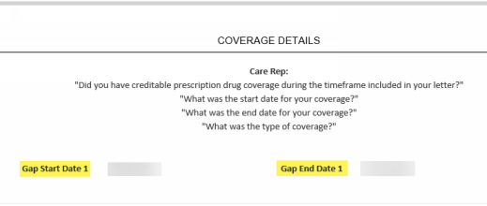  For each span of coverage being reported by the caller:  - Record the Creditable Coverage Start date using the calendar icon.  - Record the Creditable Coverage End date using the calendar icon.  - Choose the type of coverage from the drop-down menu  - To add additional spans of coverage, use the [+] icon to the right of the screen.  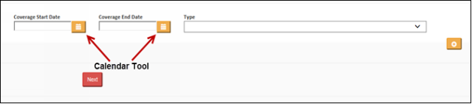  - Click the Calendar icon next to the date field.  - Select the year that coverage began/ended by clicking on the Month/Year at the top of the calendar.  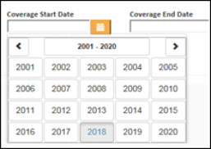  Note: Use the arrows to move the range of years.  - Select the month that coverage began/ended.  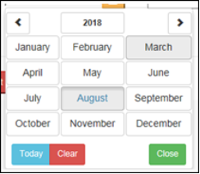  - Select the day of the month provided by the beneficiary. If the beneficiary only knows the month and year, select the 1st of the month.  Result: The date will populate in the date field.  If the beneficiary is attesting that their coverage started in a year prior to the gap dates shown on the Coverage Details Screen, it is acceptable to use the start month/year of the Gap Start Date (shown below) as the Coverage Start Date.    When all spans of creditable coverage are entered, click on Next to proceed to the Confirm Attestation Screen.  Proceed to next step.
5 | To submit a verbal attestation | 4 | - (Caller Name) do you attest that the information that you have provided is true and correct to the best of your knowledge?  - Therefore, do I have your authorization to submit your Attestation information to Medicare to review on your behalf?  - Thank you, (Caller Name), we at <Blue MedicareRx (NEJE)> will forward the information to Medicare. Once Medicare receives your information, we (the plan) will send you a written notification regarding their decision.  If caller agrees with the disclaimer: Select Yes.  If caller does not agree with the disclaimer: Select No.  Copy comments to use in Closing the Call for Participant Inquiry Tab.  If the legal representative does not have the appropriate information for verbal attestation, advise the caller to fill out the Declaration of Prior Prescription Drug Coverage form that was previously mailed to the beneficiary and mail to:  Blue MedicareRx  PO Box 30001  Pittsburgh, PA 15222-0330  OR fax to: JE Fax 866-342-7048  Blue MedicareRx (NEJE): MED D - Blue MedicareRx (NEJE) - LEP Verbal Attestation Form)
6 | Proceed to Closing the Call.

Top of the Document

Resolution Time
Resolution time will vary.

Top of the Document

LEP Appeal Process
The Late Enrollment Penalty (LEP) appeal process is available to all beneficiaries who have an existing LEP, assessed by a prior plan and/or who were assessed an LEP by the current plan and are no longer within the 90-day timeframe to attest.
- A beneficiary may request a Reconsideration packet be mailed to their mailing address from their current plan, a prior plan or from CMS.

It is the responsibility of the beneficiary or the beneficiary’s POA to complete the Reconsideration packet and mail or fax the forms to the Independent Review Entity (IRE), contracted with CMS). C2C Innovative Solutions is the current IRE contracted by CMS.
- This begins the LEP appeal process.
- The IRE will request a Case file packet be created for each Part D Prescription Drug Plan the beneficiary has ever been enrolled in (current and prior).
- The IRE will gather all information required and make one of the decisions below:

Favorable | - A decision was made that the beneficiary’s LEP will need to be reset to zero.  - The beneficiary will receive a refund for all LEP previously paid
Partially Favorable | - The IRE agrees partially with the plan and partially with the beneficiary.  - The LEP will need to be updated and the beneficiary may or may not receive a refund depending on the details of the decision.
Unfavorable | - A decision was made that the current LEP is correct, and no changes will need to be made.  - The beneficiary’s LEP remains as-is.
Dismissed/Withdrawn Decision | - A decision was made that there was not enough, or valid information given to make one of the decisions above.

Follow the steps below:
Step | Action
1 | Identify the beneficiary’s LEP in PeopleSafe.
2 | Identify the beneficiary’s concern with the LEP correspondence.  REMINDER: The Member Services team knows to whom they have sent Reconsideration Forms, however that team rarely learns whether the beneficiary actually completed the form and submitted it to the IRE.  - Once a decision is made, each Part D plan that the beneficiary had ever been enrolled in, will be notified of the decision.  - It is the plans responsibility to make the necessary updates.
2 | If the beneficiary states they… | Then the CCR will …
2 | Do not understand what the LEP is | - An LEP is a penalty amount that is added to your monthly premium due to not enrolling in a Part D prescription drug plan when you are 1st eligible and have 63 days or more of no creditable coverage.  - Did not have prior prescription drug coverage (creditable coverage) that meets the Medicare standard for Creditable Drug Coverage.
2 | Do understand the LEP however, they had creditable coverage, or they are disputing the amount that is being assessed | - Advise the beneficiary that a reconsideration form was mailed with their LEP letter.  - Validate the beneficiary’s address
2 |  | Step | Action
2 |  | 1 | From the Medicare D Inquiry Tab page, navigate to the Fulfillment Requests section.  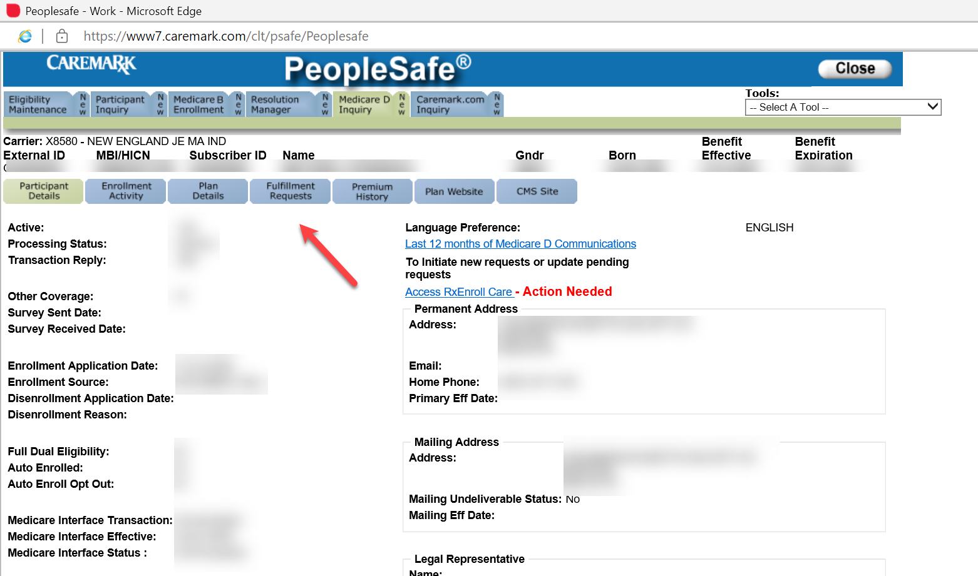
2 |  | 2 | Select LEP IRE Reconsideration from the Fulfillment List and click the Add button. Then, confirm the beneficiary’s address is correct and click on the Save Order button to send the form to the address listed.  Note: If the address is incorrect or the beneficiary requests a different address, click the Change Address button to change the address in the PeopleSafe Inquiry Tab.  Any changes must also be completed in RxEnroll Care and the Participant Inquiry section of PeopleSafe. Refer to Med D – Address Changes and Out of Area.  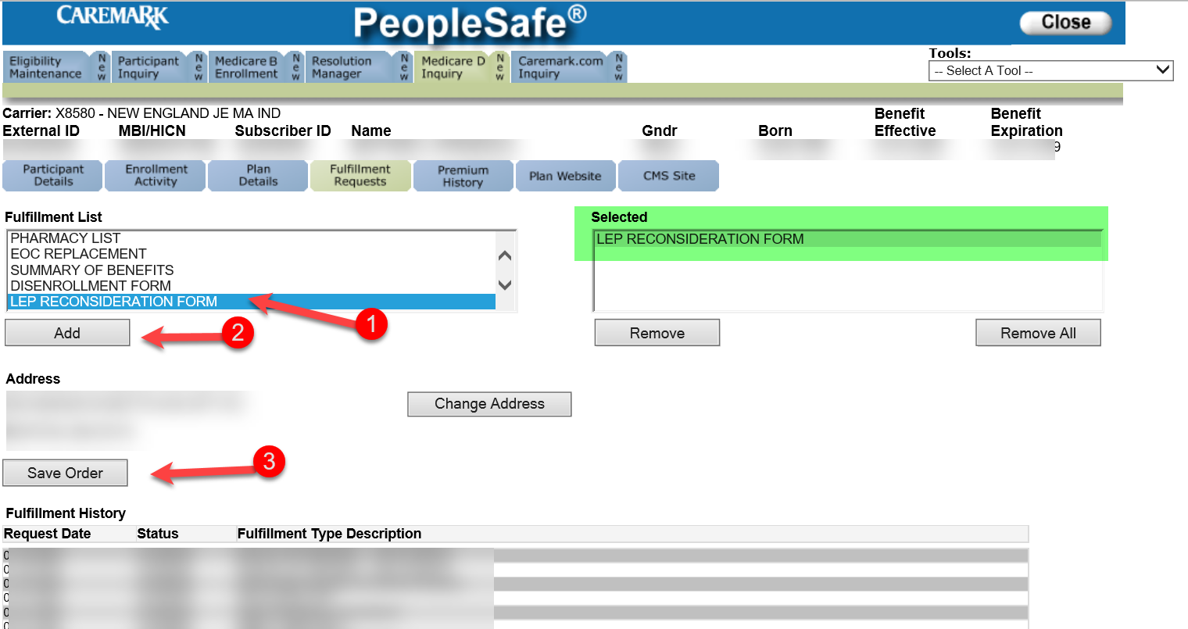
2 |  | 3 | You should receive the form within 5-7 business days.
3 | Do you have any other questions regarding the information we have discussed today?
3 | If… | Then…
3 | Yes | Utilize the FAQs section of this document in order to address any additional questions.
3 | No | Proceed to the next step.
4 | - Thank you for your time today.  - As a quality measure, have I fully answered and resolved your question(s) to your satisfaction?
4 | If… | Then…
4 | Yes | If at any time you have further questions about this communication, please feel free to call Customer Care toll free at:  MA: 888-543-4917  CT: 888-620-1747  RI: 888-620-1748  VT: 888-620-1746  <24 hours a day, 7 days a week>  - TTY users call <711>  CCR Process Note:  Document and close the call according to current policies and procedures.  Refer to the MED D - Call Documentation.  Log Activity:  1327 - Premium Billing  1328 – LEP/TRC Attestation  Resolution Time:  The beneficiary has 30 days from the date of the LEP letter to attest their LEP.
4 | No | - Ask additional probing questions to attempt to resolve remaining questions or concerns.  - If unable to resolve the questions/concerns, transfer the call to a Supervisor.  CCR Process Note:  Document and close the call according to current policies and procedures.  Refer to the MED D - Call Documentation.  Log Activity:  1327 - Premium Billing  1328 – LEP/TRC Attestation  Resolution Time:  The beneficiary has 30 days from the date of the LEP letter to attest their LEP.
The beneficiary cannot file a Grievance regarding to the amount of the LEP. The only available option is to follow the process outlined within this document.

If the beneficiary wishes to file a Grievance surrounding the process of filing a LEP Appeal (i.e., Filling Out Forms, sending documents, etc.) this is an acceptable Grievance submission.

Top of the Document

Reconsideration Requests (LEP Appeals)

Reconsideration requests (Appeals) for a Late Enrollment Penalty are not handled directly by the Plan. an Independent Review Entity (IRE) as assigned by Medicare (CMS). It is the responsibility of the beneficiary or the beneficiary’s POA to complete a Reconsideration packet and mail or fax the forms to an Independent Review Entity (IRE), contracted with Medicare.

The current IRE is C2C Innovative Solutions. For more information on the appeals process and to obtain a Reconsideration request Form, the beneficiary can visit:

https://partdappeals.c2cinc.com// - Click on Part D Enrollees & Representatives and then Forms.

The beneficiary may also visit the following website to obtain the form, but the form must be filed with C2C Innovative Solutions:

https://www.cms.gov/Medicare/Appeals-and-Grievances/MedPrescriptDrugApplGriev/Late-Enrollment-Penalty-LEP-Appeals

Important Process Note: Do NOT under any circumstances refer the beneficiary or a third party to Medicare.

Step | Action
1 | - If you do not agree with your Late Enrollment Penalty, you can ask Medicare for a review or reconsideration by submitting a Part D Late Enrollment Penalty Reconsideration Request Form.  - You will have the chance to provide proof that supports your case, like information about Creditable Prescription Drug Coverage.  - If you need help completing the form you can contact your State Health Insurance Assistance Program (SHIP).  Note: The Member Services team knows to whom they have sent Reconsideration Forms, however that team rarely learns whether the beneficiary completed the form and submitted it to the IRE.  - Once a decision is made, each Part D plan that the beneficiary had ever been enrolled in, will be notified of the decision.  Proceed to the next step.
2 | You should have received a reconsideration request form with your previous LEP notice. Do you have this form, or do you need a replacement form?
3 | From the Medicare D Inquiry Tab page, navigate to the Fulfillment Requests section.
4 | Select LEP IRE Reconsideration from the Fulfillment List and click the Add button. Then, confirm the beneficiary’s address is correct and click on the Save Order button to send the form to the address listed.  Note: If the address is incorrect or the beneficiary requests a different address, click the Change Address button to change the address in the PeopleSafe Inquiry Tab.  Any changes must also be completed in RxEnroll Care and the Participant Inquiry section of PeopleSafe. Refer to Med D – Address Changes and Out of Area.
5 | You should receive the form within 5-7 business days.  Proceed to Closing the Call.

Top of the Document

Closing the Call

Perform the following:
Step | Action
1 | From the Participant Inquiry tab click on the Capture Activity button on the bottom left of the screen.
2 | Document in Capture Activity and Med D Inquiry Comments by adding a comment  Close the call according to current policies and procedures.  In the Log Activity Notes field, use the RxEnroll comments to document the call.
3 | Click on Save Changes.
4 | - Thank you for your time today.  - As a quality measure, have I fully answered and resolved <your/the beneficiary’s> question(s) to <your/the beneficiary’s> satisfaction?
4 | If… | Then…
4 | Yes | Close the call:  - Address any benefit issues.  - Document and close the call according to existing policies and procedures, including all options discussed.  Note: Refer to the MED D - Call Documentation Including Viewing and Adding Comments in PeopleSafe Work Instruction.
4 | No | - Ask additional probing questions to attempt to resolve remaining questions or concerns.  - If unable to resolve the questions/concerns, transfer the call to a Senior Team.  Log Activity:  1327 - Premium Billing  1328 – LEP/TRC Attestation
5 | If needed, transfer the beneficiary to the appropriate department.

Top of the Document

Resolution Time
7 days upon receipt of request/attestation.

Top of the Document

Exceptions

Beneficiaries who qualify for the Extra Help Subsidy (LIS) are exempt from an LEP beginning with the effective date of their LIS. For example, if a beneficiary had eight uncovered months prior to their LIS effective date, their total number of uncovered months should be set to zero with the effective date being the effective date of their LIS eligibility or the effective date of the plan, whichever comes later.
- If a beneficiary was charged an LEP prior to gaining LIS eligibility, the beneficiary is responsible for any unpaid LEP amount owed prior to the effective date of their LIS eligibility; and the Part D plan shall bill and collect the owed amount.
- If a beneficiary loses his/her LIS eligibility AND experiences a gap in coverage for 63 days or greater, the beneficiary would be subject to a new late enrollment penalty.

Beneficiaries who had creditable prescription drug coverage instead of Part D are exempt from the penalty as long as they enrolled in a Part D plan within 63 days of losing their creditable coverage.

Medicaid and the Social Security Administration provide Low Income Subsidy (LIS), also known as Extra Help, to beneficiaries in order to assist with expenses involved with prescription drugs. People who have questions about filling out the application for Extra Help should visit www.socialsecurity.gov on the web or call Social Security at 1-800-772-1213. They can also refer the beneficiary to Medicare.gov to read the Medicare and Me information about Extra Help located in section 3.

Your state may have programs to help you pay your prescription drug costs. Contact your state Medicaid office or State Health Insurance Assistance Program (SHIP) for more information. Visit shiptacenter.org or call 1-800-MEDICARE (1-800-633-4227) for the phone number of your SHIP. TTY users should call 1-877-486-2048.

Top of the Document

FAQs

The CCR should use the following table to answer additional questions:
Question | Answer
- Why am I being assessed an extra fee on my monthly premium? | - You received an attestation form to complete to attest to prior prescription drug coverage.  - The plan has determined you had a lapse in coverage greater than 63 days.  - When this occurs, the plan informs CMS so that CMS can compute the LEP in those cases where a penalty is owed.
2. What is a Late Enrollment Penalty (LEP)? | The Late Enrollment Penalty (LEP) is a penalty amount assigned by Medicare when it is determined the beneficiary did not join a Medicare drug plan when HE/SHE first became eligible, or if HE/SHE went without prescription drug coverage (creditable coverage) for a period of 63 days or more. Medicare defines creditable coverage as prescription drug coverage that equals or exceeds the actuarial value of defined standard Part D prescription drug coverage, (coverage that is at least as good as Medicare’s prescription drug coverage). Unless the beneficiary can attest to having creditable coverage during the time period in question, HE/SHE will have to pay the LEP each month as long as HE/SHE has Medicare prescription drug coverage, even if HE/SHE changes Medicare drug plans. For these beneficiaries, the LEP is added to the plan’s monthly premium.
3. How is the Late Enrollment Penalty calculated? | Medicare, not the Plan, calculates the LEP when a beneficiary subject to the penalty first joins a Medicare drug plan. The LEP amount typically is 1% of the national base beneficiary premium (also called ‘base beneficiary premium’) for each full, uncovered month that the beneficiary did not have Part D or creditable coverage. The monthly penalty is rounded to the nearest $0.10 and added to the monthly Part D premium. The LEP may change each year because the national base premium can change each year. If the national base premium (as determined by Medicare) increases, the penalty will increase.
4. Why you are asking me to attest? Doesn’t Medicare/CMS have this information? | - I understand your concern.  - However, we are required to obtain this information from you, because Medicare/CMS may not have information regarding other plan health coverage.
5. Why did I receive this letter Model Notice of Yearly Change to LEP letter (Exhibit 9)? | - All Blue MedicareRx (NEJE) beneficiaries with existing LEP receive this notice.  - You received this letter to notify you of any changes to your LEP amount.  Refer to MED D - Exhibit 9 NEJE Model Notice of Yearly Change to LEP S2893_15157_LEP.
6. How was I notified of this LEP amount? | You will have either received the Model Notice of Yearly Change to LEP letter (Exhibit 9) or will have been notified via message on your December (January premium) Invoice with the LEP amount.  Refer to MED D - Exhibit 9 NEJE Model Notice of Yearly Change to LEP S2893_15157_LEP.
7. What is creditable coverage? | - To qualify as creditable coverage, a prescription drug plan must have benefits that are at least as good as Medicare’s most basic plan.  - A prescription drug plan is recognized as providing creditable coverage once an actuary has evaluated the plan and found it to be equivalent to the Medicare Part D Basic Plan.
8. I did not have a period where I was without Medicare Part D coverage or its equivalent.  How can I appeal this penalty? | - I understand.  - Late enrollment penalties are determined by CMS (Medicare).  - You do have the right to appeal the Late Enrollment Penalty.  - I will be happy to request a Reconsideration Packet for you to appeal the Late Enrollment Penalty decision with the IRE. Or I can provide you with information on how to appeal the decision directly with C2C Innovative Solutions, Medicare’s independent contractor.  - The IRE will review a beneficiary’s request to reconsider the imposition of a Late Enrollment Penalty.  - The IRE has 90 days from the receipt of the appeal to decide and a letter will be sent from C2C Innovative Solutions to the beneficiary with the final decision.  - They may be contacted at:  C2C innovative Solutions, Inc.  Part D LEP Reconsiderations  PO Box 44165  Jacksonville, FL 32231-4165  Expedited Appeals Fax Number: 1-833-710-0579  Standard Appeals Fax Number: 1-833-710-0580  LEP Appeals Fax Number: 1-833-946-1912  CCRs CANNOT contact C2C Innovative Solutions.  - The above information is the preferred method of contact.  - They can also be contacted via phone: 1-833-919-0198 or through the internet at: https://PartDAppeals.C2Cinc.com.

Top of the Document

Related Documents

- Grievance Standard Verbiage (for use in Discussion with Beneficiary) section in MED D - Grievances Index
- MED D - Blue MedicareRx (NEJE) - LEP Verbal Attestation Form
- MED D - Exhibit 9 NEJE Model Notice of Yearly Change to LEP S2893_15157_LEP
- Universal Medicare D - Consultative Call Flow (CCF) Process

Parent SOP: CALL-0048: Medicare Part D Customer Care Call Center Requirements-CVS Caremark Part D Services, L.L.C.
Abbreviations/Definitions: Abbreviations / Definitions

Top of the Document

Not to Be Reproduced or Disclosed to Others without Prior Written Approval
ELECTRONIC DATA = OFFICIAL VERSION - PAPER COPY = INFORMATIONAL ONLY

